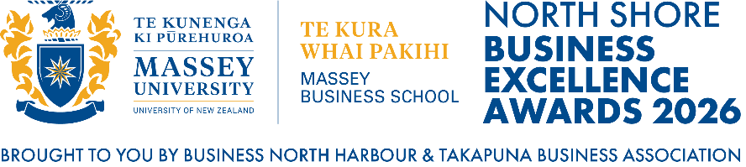

THE BNH EXCELLENCE IN INNOVATION AWARD
Proudly Sponsored by

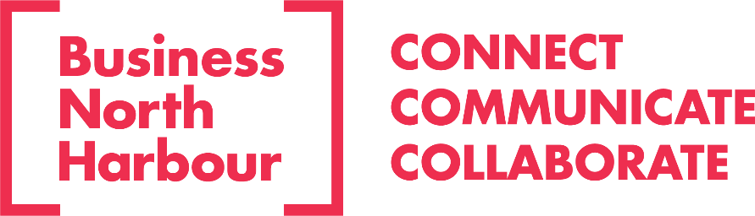

Business North Harbour is a non-profit organisation who for more than 20 years, has been advocating for the growth and prosperity of our business community. BNH empowers the people and enterprises that make our district thrive, and provide opportunities for members to connect, communicate, and collaborate.
-------------------------------------------------
This award celebrates a business that has delivered measurable success through a standout innovation — whether a product, service, technology, sustainability initiative or operational improvement. It recognises organisations that challenge convention, create meaningful value and demonstrate clear, evidence-based impact.
-------------------------------------------------
DETAILS OF ENTRANT:
Nominee / Name of Business:
Business Owner’s Name:
Physical Business Address:
Phone:
Email:
What is the primary industry of your Business?
Is this innovation under Patent? (if relevant)
Nominator / Name of person completing this entry form:
Phone:
Email:
Alternate Contact:

-------------------------------------------------
QUESTION 1
Describe the new product, service, or process you developed

This box will adjust in size as you type into it. It is not indicative of the maximum 500-word count.

-------------------------------------------------
QUESTION 2
What problem or need does it solve?

This box will adjust in size as you type into it. It is not indicative of the maximum 500-word count.

-------------------------------------------------
QUESTION 3
How is it different from existing solutions?

This box will adjust in size as you type into it. It is not indicative of the maximum 500-word count.

-------------------------------------------------
QUESTION 4
What results, uptake, or feedback have you seen?

This box will adjust in size as you type into it. It is not indicative of the maximum 500-word count.

-------------------------------------------------
QUESTION 5
What improvements or next steps are planned?
This box will adjust in size as you type into it. It is not indicative of the maximum 500-word count.

-------------------------------------------------
ADDITIONAL INFORMATION
Please provide any additional information that you think may be relevant to your application. (Max 500-words)

This box will adjust in size as you type into it. It is not indicative of the maximum 500-word count.

TERMS AND CONDITIONS OF ENTRY INTO THE NORTH SHORE BUSINESS EXCELLENCE AWARDS

Please read and sign in acceptance below.

TERMS OF ENTRY:
- No entry fee is required to enter the awards.
- Entries and supporting documents (where requested/applicable) are due at the time of submission.
- The judges’ decisions are final, and no correspondence will be entered into. BNH reserves the right to revoke an award or finalist nomination if deemed necessary.
- Shortlisted finalists may be required to verify the information they have submitted if the evidence provided is not sufficient.
- All entrants must be current full Business North Harbour or Takapuna Business Association Members. Associate Members may not enter the Awards.
- Awards Finalists may request a North Shore Business Excellence Awards media pack to use to promote their achievements. The use of the North Shore Business Excellence Awards logo marks and rights are not permitted unless permission is granted in writing by BNH.
- The entrant agrees to disclose any pending claims or litigation that may be held against the company or company directors or any other relevant party.
- Entries close at 12.00pm on 7 August 2026. No entries will be accepted after this date.
- All information received and submitted will be treated in the strictest confidence.

JUDGING PROCESS:
- We strongly encourage you to complete as many sections as possible, to give the judges a good overview of your business. At the time of judging, the judges will also consider your entry for additional Award categories as they deem appropriate.
- At all stages, judges score independently of other judges. Judges are required immediately to declare any conflict of interest and BNH will exclude any judge with conflicts of interest from judging these categories.
- During Stage one, a shortlist of finalists is identified.
- During Stage two, short listed entries will be contacted and will be interviewed in person or online for final judging. During this stage, other elements such as Health and Safety / Quality and Systems, Strategic Planning, Employee Engagement and/or People Management may also be evaluated. This is an informal process and is aimed to get to know you better.
- A winner and runner up will be decided and will be announced, at the North Shore Business Excellence Awards Gala Dinner to be held on the 13th of November 2026. Each Finalist will receive two complimentary tickets to the event, and additional tickets can be purchased.

ENTRY FEEDBACK:
- The Judging panel will be made up of experts in their field, so we encourage you to be as detailed as possible in your application. Our expert panel of judges are unable to provide feedback to every entrant. If you wish to receive individual feedback, our judging panel will endeavour to provide this on a case-by-case basis. Please email awards@businessnh.org.nz to make a request for feedback. Feedback requests will only be accepted between the 16th of November 2026 and the 10th of December 2026.

PRIVACY OF DATA & SUBMISSION INFORMATION:
- The personal and business information provided will be held in confidence for the purpose of your Awards submission only. You hereby acknowledge that the data and information provided in this entry will be used and stored in confidence by BNH and associated judges.

CLOSING DATE FOR ENTRIES
- Entries can be submitted until the closing date of 7 August 2026 at 12.00pm.
- No entries will be accepted after this date.

I agree to the above terms and conditions:

Signature: __________________________________________________________________
Date: ___________________________________________________________________

Please refer any queries to: awards@businessnh.org.nz or call Debbie Cannon on
029 123 7773.

